Potential Home Based Learning Timetable for Year 3 Summer Term 2020 W/b: 6/7/20

deputy@sandiway.cheshire.sch.uk or khandley@sandiway.cheshire.sch.uk

As always there is no expectation here but just do as much as you can and try your best. Remember to send us any work you do on Padlet so we can see what you have been doing.

This week I would like you to email me your conjunctions work please and I will send you some brief feedback as soon as I can.

Mix and Match the timetable to suit your own time availability.
The only sessions that need to be done in the order given is the work set from the Oak National Academy website.

 | Monday | Tuesday | Wednesday | Thursday | Friday
9:00 | PE  Try I moves | PE  Try Go Noodle | PE  Try Just Dance | PE  Try Go Noodle | PE  Try Jump Start Johnny
9:30-9:45 | Mental Maths  Times table practise of 2,3,4,5,8, and 10 times table  Play hit the button  www.topmarks.co.uk/maths-games/hit-the-button | Mental Maths  Try the emoji multiplication mosaic | Mental Maths  Times table practise of 2,3,4,5,8, and 10 times table  Play hit the button  www.topmarks.co.uk/maths-games/hit-the-button | Mental Maths  Either continue the Emoji multiplication mosaic  or  try the  Emoji Code breaking sheet | Mental Maths  Times table practise of 2,3,4,5,8, and 10 times table  Play hit the button  www.topmarks.co.uk/maths-games/hit-the-button
9:30 | Maths:  Using the Oak National Academy website  www.thenational.academy/online-classroom/year-3/maths#subjects  Please complete the Measures  Lesson 6  Compare capacity and volume | Maths:  Oak National Academy  Please complete the Measures  Lesson 7  Order capacity and volume | Maths:  Oak National Academy  Please complete the Measure lessons  Lesson 8  Add and subtract capacity and volume | Maths:  Oak National Academy  Please complete the Measure lessons  Lesson 9  Solve problems involving capacity and volume | Maths:  Oak National Academy  Please complete the Measure lessons  Lesson 10  Estimate mass and capacity
10:30 | Break
10:45- 11:10 | Reading  Quiet Reading of an appropriately pitched text | Reading  Discussing book preferences  Complete a book review and upload it onto Padlet | Reading  Bug club | Reading  Picking out the main events in a story  Choose a story you’ve recently really enjoyed.  Bullet point the main events of the story in no more than five bullet points. | Reading  Quiet Reading  As well as books, you may enjoy reading the First News (children’s newspaper), comics, magazines, recipes,
11 10- 12:10 | English:  Using the Oak National Academy website  www.thenational.academy/online-classroom/year-3/english#subjects  This week we are starting the genre:  Letters  Do Lesson 1 today  Reading comprehension- Summary | English:  Oak National Academy  Genre Focus:  Letters  Do Lesson 2 today  Reading comprehension:  Word meaning | English:  Oak National Academy  Genre Focus:  Letters.  Do Lesson 3 today  Identifying the features of a text | English:  Oak National Academy  Genre Focus:  Letters.  Do Lesson 4 today  GPS focus- Subordinate clauses | English:  Oak National Academy  Genre Focus:  Letters.  Do Lesson 5 today  To write a letter
12:10-1.10 | Lunchtime
1:00-1:20 | GPS  Spelling and handwriting:  This week, practise your joined cursive handwriting whilst also practising your spelling using the Y3 handwriting sheets | GPS  Grammar:  Conjunctions  Complete Cameron’s conjunction challenge | GPS  Spelling and handwriting:  As Monday | GPS  Grammar:  Conjunctions  Complete Colin’s  co-ordinating  conjunction challenge | GPS  Spelling and handwriting:  As Monday
1.15-3:15 | History  Reflect on your Egyptian learning.  What is the same and what is different about life in the Ancient Egyptian times compared to living in 2020?  Has the Ancient Egyptian civilisation influenced our lives today? If you think it has, how? | Computing  Explore Purple Mash  There are activities saved for you to practise your touch typing skills which would be very useful.  Mrs Handley has said that this is on the alerts that she has set for you. | PE  Possible ideas:  volleyball,  How many keepie uppies can you do?  Dance to your favourite music- non-stop for as long as you can!  See the suggested list of websites for Getting Active at Home | Science:  This week is learning all about magnets. There is a powerpoint presentation and a worksheet  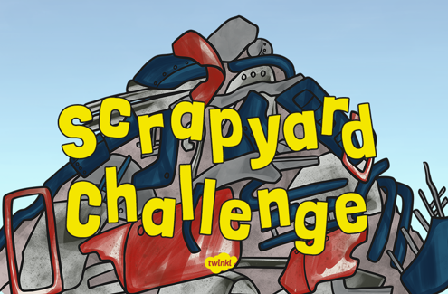 | Well-being Activity  Possible Ideas:  reading for pleasure,  bake a cake,  do some gardening,  get wet by washing your parents car,  build with lego,  Mindfulness colouring,  yoga,  drawing with Rob Biddulph,

