Potential Home Based Learning Timetable for Year 3 Summer Term 2020 W/b: 15/6/20

deputy@sandiway.cheshire.sch.uk or khandley@sandiway.cheshire.sch.uk

Have a look at this week’s video message: https://youtu.be/kJthhR6enPE

As always there is no expectation here but just do as much as you can and try your best. Remember to send us any work you do on Padlet so we can see what you have been doing.

This week I would like you to email me your Egyptian glossary and/or your adventure story please and I will send you some brief feedback as soon as I can.

Mix and Match the timetable to suit your own time availability.
The only sessions that need to be done in the order given is the work set from the Oak National Academy website.

 | Monday | Tuesday | Wednesday | Thursday | Friday
9:00 | PE  Joe Wicks- The daily body coach workout  https://inews.co.uk/news/education/joe-wicks-youtube-workout-kids-pe-lessons-live-watch-uk-when-time-2505733 | PE  You may choose an Alternative to the Body coach  Les Mills Born to Move  https://www.youtube.com/watch?v=9WgkiB-GQMI | PE  You may choose an Alternative to the Body coach  Minecraft Yoga.  https://www.youtube.com/watch?v=02E1468SdHg | PE  Joe Wicks- The daily body coach workout  or an alternative exercise of your choice | PE  Joe Wicks- The daily body coach workout  or an alternative exercise of your choice
9:30-9:45 | Mental Maths:  Mad Minutes 5x table  (or equivalent daily multiplication/ times tables practise) | Mental Maths:  Mad Minutes 3 x table | Mental Maths:  Mad Minutes 4x table | Mental Maths:  Mad Minutes 8 x table | Mental Maths:  Mad minutes 2 x table or 10 times table  Also work on division facts for these times tables.
9:30 | Maths:  Using the Oak National Academy website  www.thenational.academy/online-classroom/year-3/maths#subjects  Please continue the work from last week on fractions.  Do Lesson 11 today  Finding equivalent fractions | Maths:  Oak National Academy  Fractions  Do Lesson 12 today  Finding equivalent fractions | Maths:  Oak National Academy  Fractions  Do Lesson 13 today  Adding fractions with the same denominator | Maths:  Oak National Academy  Fractions  Do Lesson 14 today  Subtracting fractions with the same denominator | Maths:  Oak National Academy  Fractions  Do Lesson 15 today  Revising Fractions  Well Done you have now covered the whole Fractions unit!
10:30 | Break
10:45- 11:10 | Reading  Quiet Reading of an appropriately pitched text | Reading  Comprehension work-  Plastic pollution- Skimming and scanning | Reading  Bug club | Reading  Comprehension work-  End plastic pollution | Reading  Quiet Reading
11 10- 12:10 | English:  Using the Oak National Academy website  www.thenational.academy/online-classroom/year-3/english#subjects  This week we are starting the genre:  Adventure Story.  Do Lesson 1 today  Reading comprehension- Predict and inference | English:  Oak National Academy  Genre Focus:  Adventure Story  Do Lesson 2 today  Reading comprehension: fact retrieval | English:  Oak National Academy  Genre Focus:  Adventure Story  Do Lesson 3 today  Identifying the features of a text | English:  Oak National Academy  Genre Focus:  Adventure Story  Do Lesson 4 today  GPS focus- Prepositions | English:  Oak National Academy  Genre Focus:  Adventure Story  Do Lesson 5 today  Story- Continue a story  
12:10-1.10 | Lunchtime
1:00-1:20 | GPS (Grammar, Punctuation and Spelling)  Key word spelling:  Choose a selection of 5 to 6 words from the Y3/4 spelling list that you need to continue working on and use the strategy below  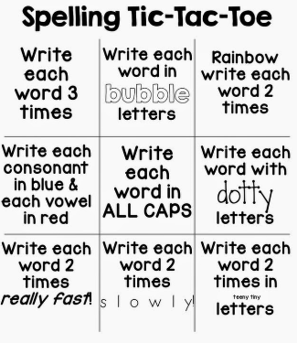 | GPS  Grammar:  Prepositions  Use the powerpoint presentation called Powerpoint on Prepositions  Then complete the Canine Preposition sheet. | GPS  Grammar:  Prepositions  Use the powerpoint presentation called Powerpoint on Prepositions  Then complete the sentence game by making and using the dice. | GPS  Spelling:  Homophones  Remember homophones are words that have the same pronunciation but different meaning and different spelling.  Complete the sheet  called Homophones | GPS  Spelling:  Homophones  Remember homophones are words that have the same pronunciation but different meaning and different spelling.  Complete the sheet  called there, their or they’re
1.15-3:15 | Topic (History)  Ancient Egyptians  Writing an Ancient Egyptian glossary  The following words need to be explained in a glossary. Think about your glossary definition and that a glossary needs to be in alphabetical order.  Sphinx,  Pharaoh,  Nile,  Sarcophagus,  Hieroglyphic,  Papyrus,  Pyramids,  Can you add any other words and definitions to your glossary? | PE  Possible ideas:  A bike ride,  a walk,  a run,  tennis,  badminton  circuits in the garden,  an obstacle course that you can time yourself on and then try to beat your time.  See the suggested list of websites for Getting Active at Home | Music  Have a go at the What am I? quiz about musical instruments  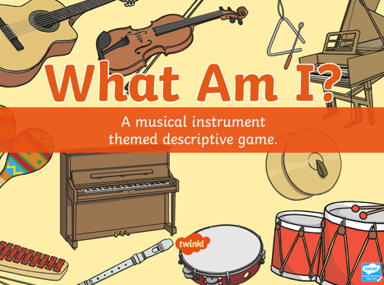  and then have a go at some of the  Musical Challenge cards | Science:  This week Mrs Handley would like you to explore the lifecycle of a flower  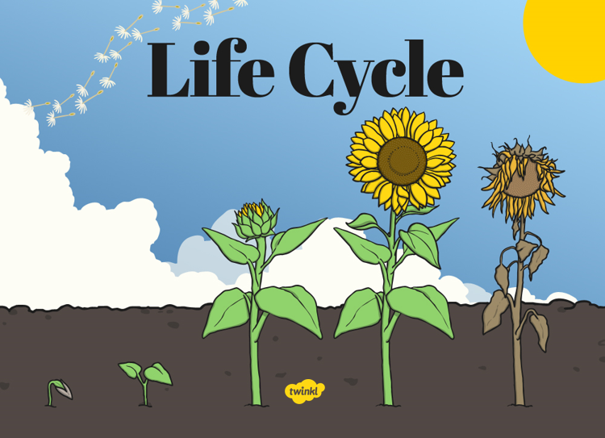  Please complete the attached sheet about The lifecycle of a flower. | Well-being Activity  Possible Ideas:  reading for pleasure,  bake a cake,  do some gardening,  get wet by washing your parents car,  build with lego,  Mindfulness colouring,  yoga,  drawing with Rob Biddulph,

