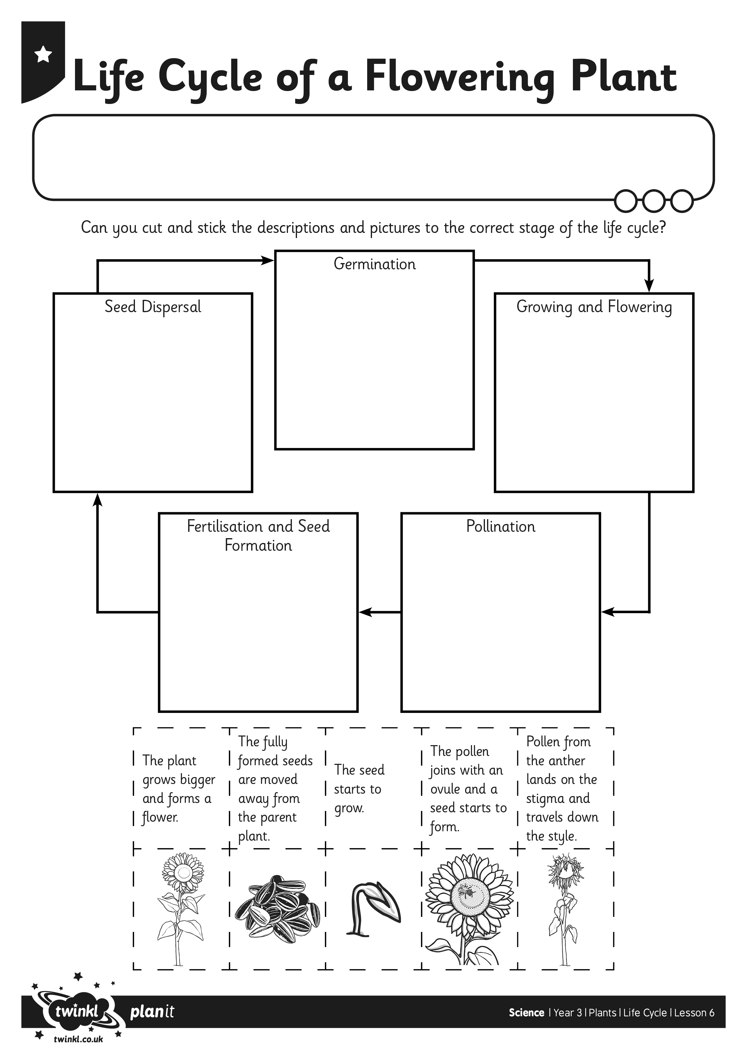
I can understand and order the stages of the life cycle of a flowering plant.
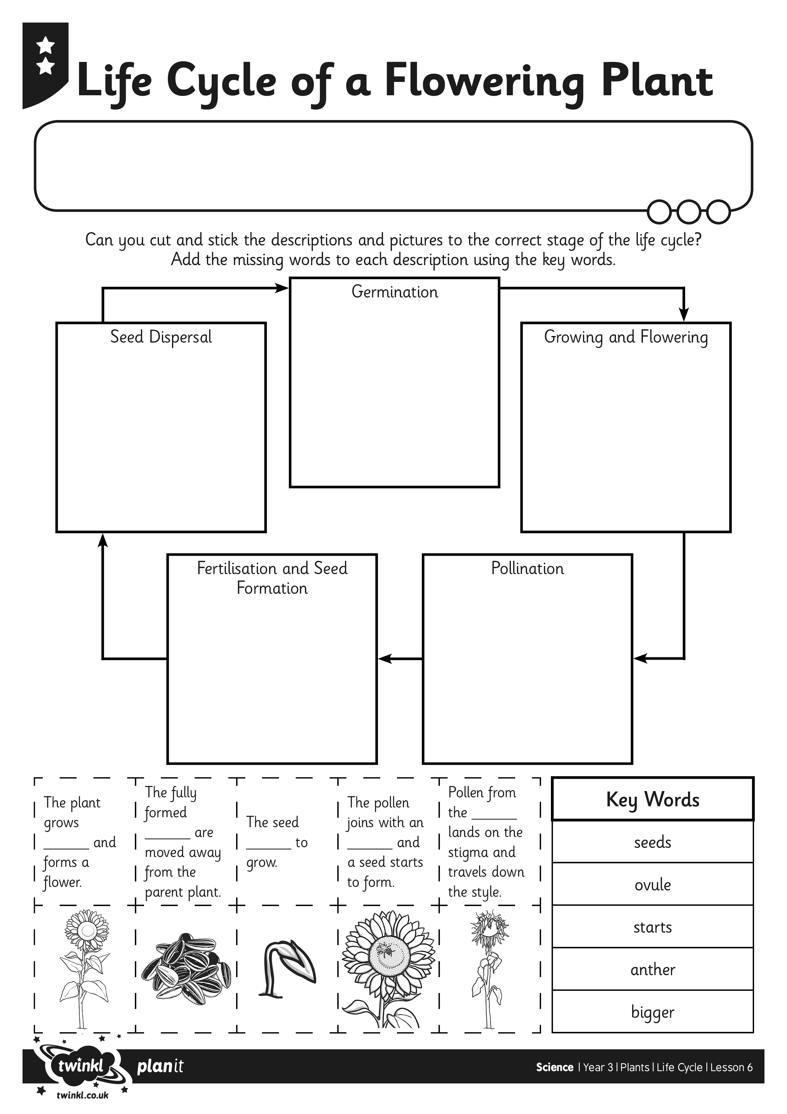
I can understand and order the stages of the life cycle of a flowering plant.

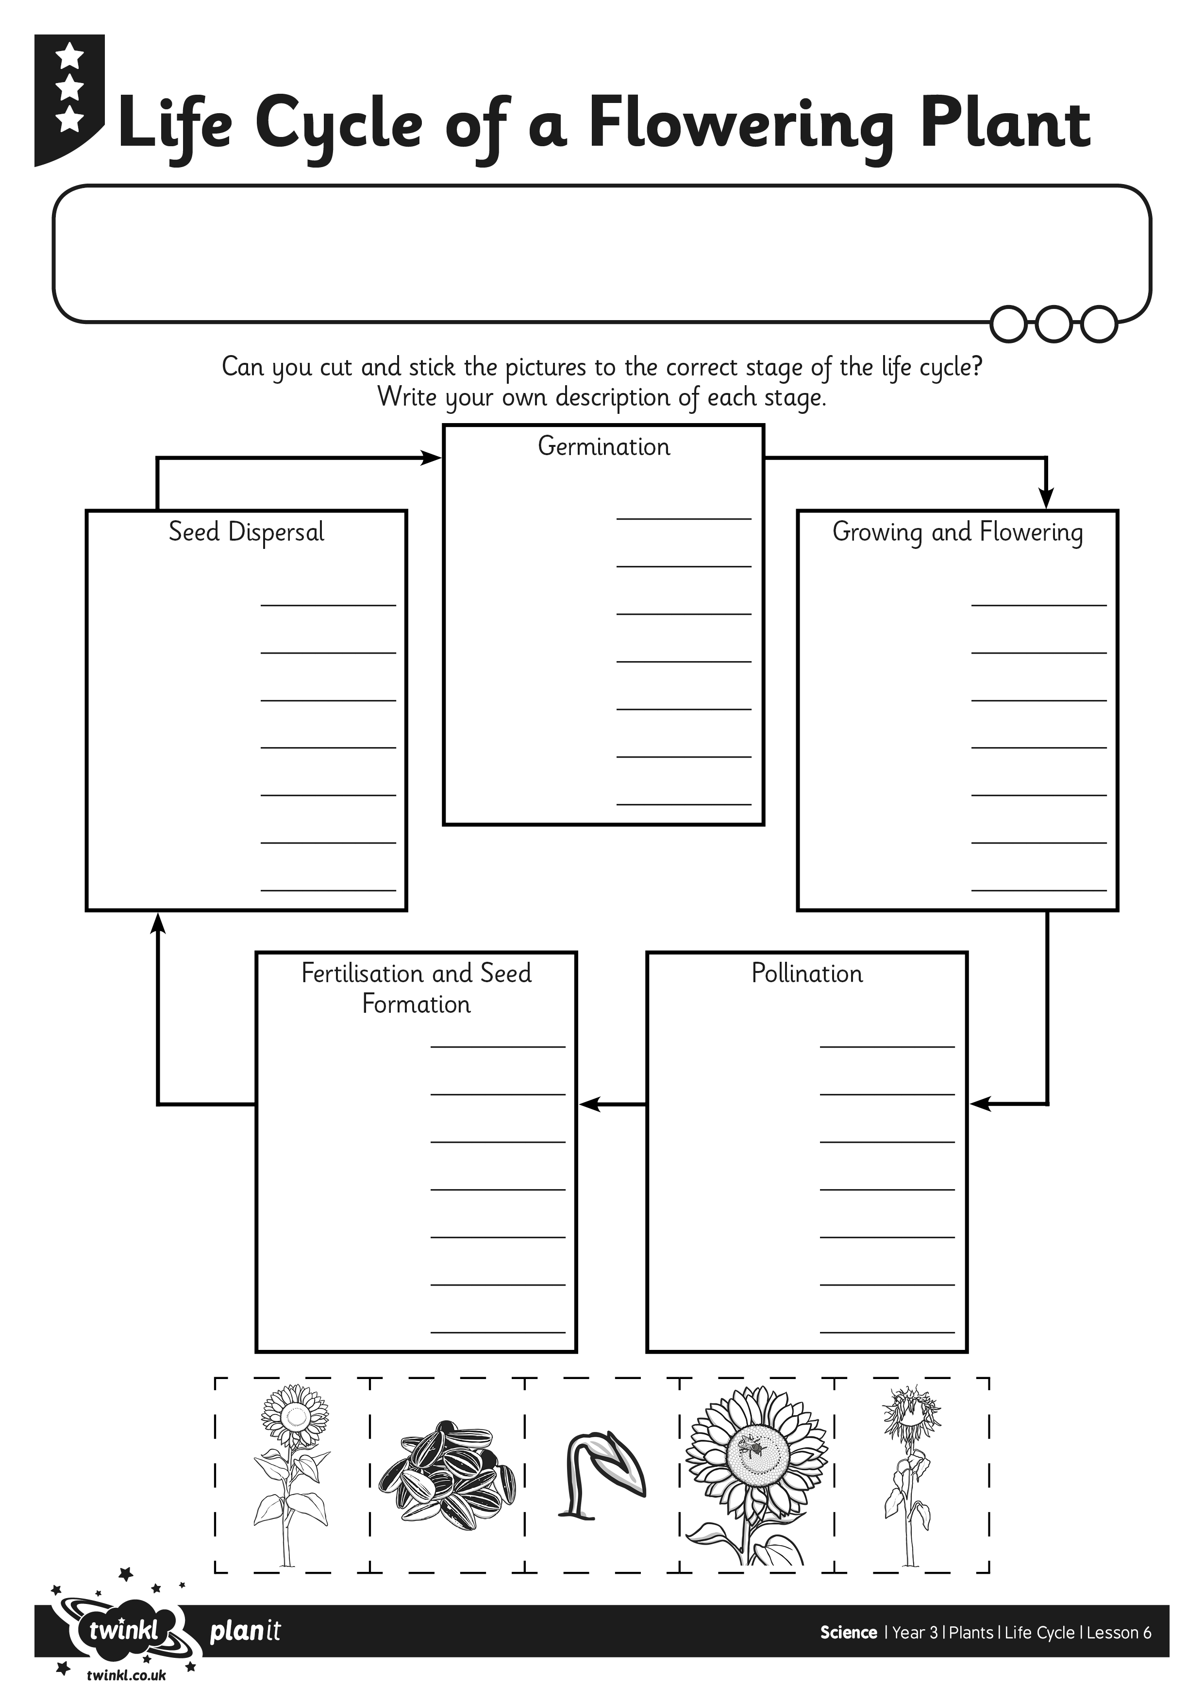
I can understand and order the stages of the life cycle of a flowering plant.

