Potential Home Based Learning Timetable for Year 3 Summer Term 2020 W/b: 8/6/20

deputy@sandiway.cheshire.sch.uk or khandley@sandiway.cheshire.sch.uk

Have a look at this week’s video message: https://youtu.be/YxGlSoiQTBQ

As always there is no expectation here but just do as much as you can and try your best. Remember to send us a close up shot of any work on Padlet so we can see what you have been doing.

This week I would like you to email me your character descriptions please and I will send you some brief feedback.

Mix and Match the timetable to suit your own time availability.
The only sessions that need to be done in the order given is the work set from the Oak National Academy website.

 | Monday | Tuesday | Wednesday | Thursday | Friday
9:00 | PE  Joe Wicks- The daily body coach workout  https://inews.co.uk/news/education/joe-wicks-youtube-workout-kids-pe-lessons-live-watch-uk-when-time-2505733 | PE  You may choose an Alternative to the Body coach  Les Mills Born to Move  https://www.youtube.com/watch?v=9WgkiB-GQMI | PE  You may choose an Alternative to the Body coach  Minecraft Yoga.  https://www.youtube.com/watch?v=02E1468SdHg | PE  Joe Wicks- The daily body coach workout  or an alternative exercise of your choice | PE  Joe Wicks- The daily body coach workout  or an alternative exercise of your choice
9:30-9:45 | Mental Maths:  Mad Minutes 5x table  (or equivalent daily multiplication/ times tables practise) | Mental Maths:  Mad Minutes 3 x table | Mental Maths:  Mad Minutes 4x table | Mental Maths:  Mad Minutes 8 x table | Mental Maths:  Mad minutes 2 x table or 10 times table  Also work on division facts for these times tables.
9:30 | Maths:  Using the Oak National Academy website  www.thenational.academy/online-classroom/year-3/maths#subjects  Please continue the work from last week on fractions.  Do Lesson 6 today  Identifying and describing non-unit fractions | Maths:  Oak National Academy  Fractions  Do Lesson 7 today  Finding non-unit fractions of quantities | Maths:  Oak National Academy  Fractions  Do Lesson 8 today  Consolidating finding non-unit fractions of quantities | Maths:  Oak National Academy  Fractions  Do Lesson 9 today  Comparing fractions with the same denominator | Maths:  Oak National Academy  Fractions  Do Lesson 10 today  Compare and order unit fractions
10:30 | Break
10:45- 11:10 | Reading  Quiet Reading of an appropriately pitched text | Reading  Order your books from home from most to least enjoyable. Consider why you’ve made the choices you have. | Reading  Bug club  (Please try to use Bug Club. Only 9 members of the class used it last week which is a shame. We do monitor usage.) | Reading  Comprehension work-  Usain Bolt Biography  1 star questions=easiest  2 star questions  3 star questions-=most challenging  (Choose the difficulty you want) | Reading  Quiet Reading
11 10- 12:10 | English:  Using the Oak National Academy website  www.thenational.academy/online-classroom/year-3/english#subjects  Please continue the work from last week on Character descriptions.  Do Lesson 6 today  Reading comprehension | English:  Oak National Academy  Genre Focus: Character Description  Do Lesson 7 today  Reading comprehension | English:  Oak National Academy  Genre Focus: Character Description  Do Lesson 8 today  Identifying the features of a text | English:  Oak National Academy  Genre Focus: Character Description  Do Lesson 9 today  Similes | English:  Oak National Academy  Genre Focus: Character Description  Do Lesson 10 today  Write a character description  By today you will, over the last couple of weeks have written a character description of both a superhero and a super villain. Send me your work via email.
12:10-1.10 | Lunchtime
1:00-1:20 | GPS (Grammar, Punctuation and Spelling)  Pyramid spelling:  Choose a selection of 5 to 6 words from the Y3/4 spelling list that you need to continue working on and use the strategy below  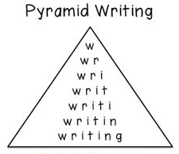 | GPS  Grammar:  Adding Conjunctions to create subordinate clauses  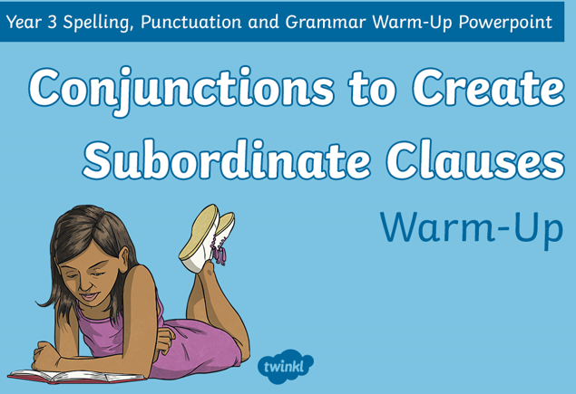  Continue with the attached powerpoint from last week. This should be completed over several sessions. | GPS  Pyramid Spelling:  (As on Monday)  Check that you are confident with the Y1 and Y2 spelling lists- Practise any you are unsure of  If you are confident with this, continue with the  Y3/4 spelling list | GPS  Grammar:  Adding Conjunctions to create subordinate clauses  This will be the final session to complete this work. | GPS  Prefix Spelling:  How many prefixes can you remember?  Make a list and then put them into sentences.
1.15-3:15 | Topic (History)  Ancient Egyptians  - Print out the Egyptian Fact cards.  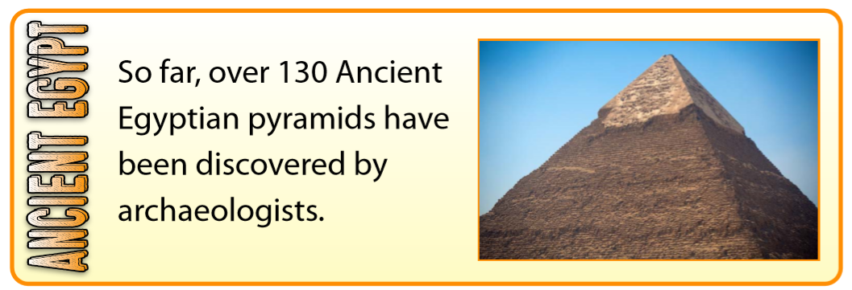  - Cut the facts up.  - Read the facts.  - Sort the facts into facts you already knew about and new facts that you didn’t already know.  - Re-sort the facts into those you find the most interesting and order them to the least interesting. There is no right or wrong answer, it is your opinion.  - Think about how Egyptologists/ historians know or have found out about these facts. | PE  Possible ideas:  A bike ride,  a walk,  a run,  tennis,  badminton  circuits in the garden,  an obstacle course that you can time yourself on and then try to beat your time.  See the suggested list of websites for Getting Active at Home | Topic (Art)  Explore colour mixing with paint to produce an Ancient Egyptian sunset.  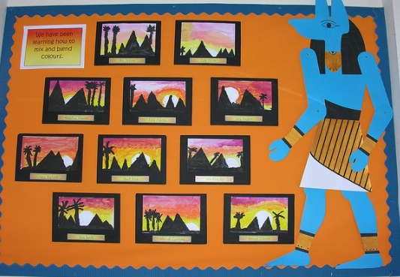  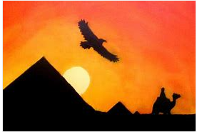 | Science:  This week Mrs Handley would like you to explore the pollination process    Please complete the attached sheet about The Pollination Process. | Well-being Activity  Possible Ideas:  reading for pleasure,  bake a cake,  do some gardening,  get wet by washing your parents car,  build with lego,  Mindfulness colouring,  yoga,  drawing with Rob Biddulph,

