Potential Home Based Learning Timetable for Year 3 Summer Term 2020 W/b: 1/6/20

deputy@sandiway.cheshire.sch.uk or khandley@sandiway.cheshire.sch.uk

This week the layout of the suggested learning activities has changed but the content is similar to that of previous weeks with a few additions. It gives you a timetable that you may choose to work to. This is a little bit more similar to what the children who are back in school will be experiencing. As always there is no expectation but just do as much as you can. Whatever you do manage to do will help you as we start to get closer to a time when we may return to school.

 | Monday | Tuesday | Wednesday | Thursday | Friday
9:00 | PE  Joe Wicks- The daily body coach workout  https://inews.co.uk/news/education/joe-wicks-youtube-workout-kids-pe-lessons-live-watch-uk-when-time-2505733 | PE  Joe Wicks- The daily body coach workout | PE  Joe Wicks- The daily body coach workout | PE  Joe Wicks- The daily body coach workout | PE  Joe Wicks- The daily body coach workout
9:30-9:45 | Mental Maths: Mad Minutes 5x table  (or equivalent daily multiplication/ times tables practise) | Mental Maths: Mad Minutes 3 x table | Mental Maths: Mad Minutes 4x table | Mental Maths: Mad Minutes 8 x table | Mental Maths: Mad Minutes (mixed/ repeat any you found tricky)
9:30 | Maths:  Using the Oak National Academy website  www.thenational.academy/online-classroom/year-3/maths#subjects  Go into the sequence of lessons on Fractions  Do Lesson 1 today  The part whole relationship | Maths:  Oak National Academy  Fractions  Lesson 2  Recognise parts that are equal and parts that are unequal | Maths:  Oak National Academy  Fractions  Lesson 3  Identify and describe unit fractions | Maths:  Oak National Academy  Fractions  Lesson 4  Find unit fractions of a given quantity | Maths:  Oak National Academy  Fractions  Lesson 5  Describe unit and non-unit fractions
10:30 | Break
10:45- 11:10 | Reading  Quiet Reading of an appropriately pitched text | Reading  Comprehension work- Garden birds comprehension | Reading  Bug club | Reading  Quiet Reading | Reading  Comprehension work- Sun Safety comprehension
11 10- 12:10 | English:  Using the Oak National Academy website  www.thenational.academy/online-classroom/year-3/english#subjects  Go into the sequence of lessons on Genre Focus: Character Description  Do Lesson 1 today  Reading comprehension | English:  Oak National Academy  Genre Focus: Character Description  Do Lesson 2 today  Reading comprehension | English:  Oak National Academy  Genre Focus: Character Description  Do Lesson 3 today  Identifying the features of a text | English:  Oak National Academy  Genre Focus: Character Description  Do Lesson 4 today  Conjunctions | English:  Oak National Academy  Genre Focus: Character Description  Do Lesson 5 today  Write a character description
12:10-1.10 | Lunchtime
1:00-1:20 | GPS (Grammar, Punctuation and Spelling)  Squiggle Spelling:  Choose a selection of 5to 6 words from the Y3/4 spelling list that you are not confident with and practise as below  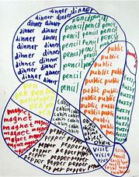 | GPS  Grammar:  Adding Conjunctions to create subordinate clauses  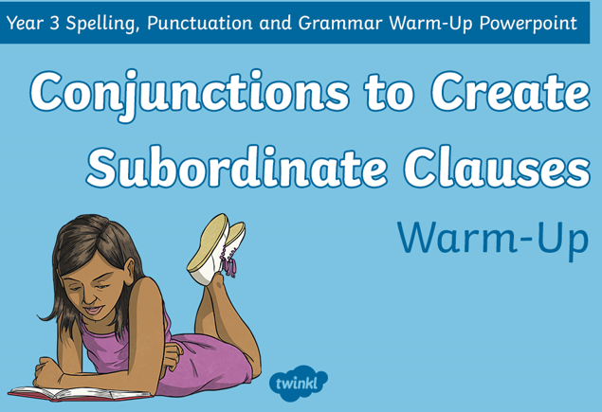  Make a start on the attached powerpoint. This should be completed over several sessions. | GPS  Squiggle Spelling:  Choose a different selection of 5to 6 words from the Y3/4 spelling list that you are not confident with and practise as below | GPS  Grammar:  Adding Conjunctions to create subordinate clauses  Continue with the attached powerpoint. This should be completed over several sessions. | GPS  Suffix Spelling:  Remind yourself by writing/drawing a poster that you can display of all the suffix rules you need to remember.  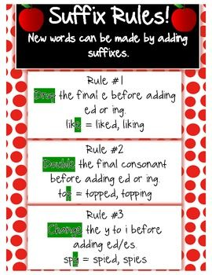  What other rules do you know?
1.15-3:15 | Topic (History)  Ancient Egyptians  What was so important about the River Nile?  What was the river used for?  How did people use the river?  Can you find out any interesting facts about the River Nile  You could draw a large map of Egypt with the River Nile running through it and then add your facts/ answers to these questions in fact boxes around it.  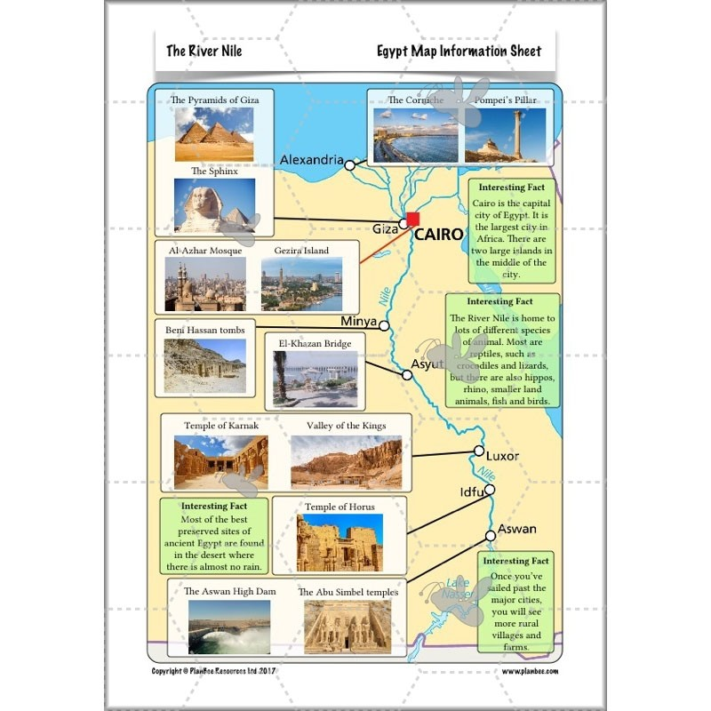 | PE  Possible ideas:  A bike ride,  a walk,  a run, tennis, badminton  See the suggested list of websites for Getting Active at Home | Topic (Art)  Take a black and white photograph of the profile of your face. Print it out  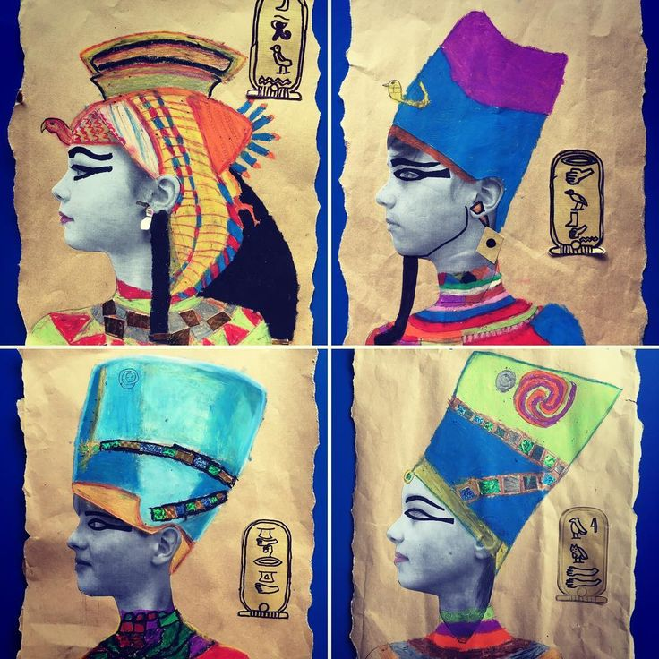  Then as the image shows above, adorn yourself as an Ancient Pharoah.  You could use oil pastels and pens. You could add your name in hieroglyphics too. | Science:  Plants  How fast does a stem suck up water?  Read through the Powerpoint    And then complete the sheet about Observing changes.  Any questions please ask Mrs Handley. | Well-being Activity  Possible Ideas:  Mindfulness colouring,  yoga,  drawing with Rob Biddulph,  reading for pleasure, watch a movie, go on a sensory walk,

Remember to send us anything you are proud of or upload it onto Padlet.

