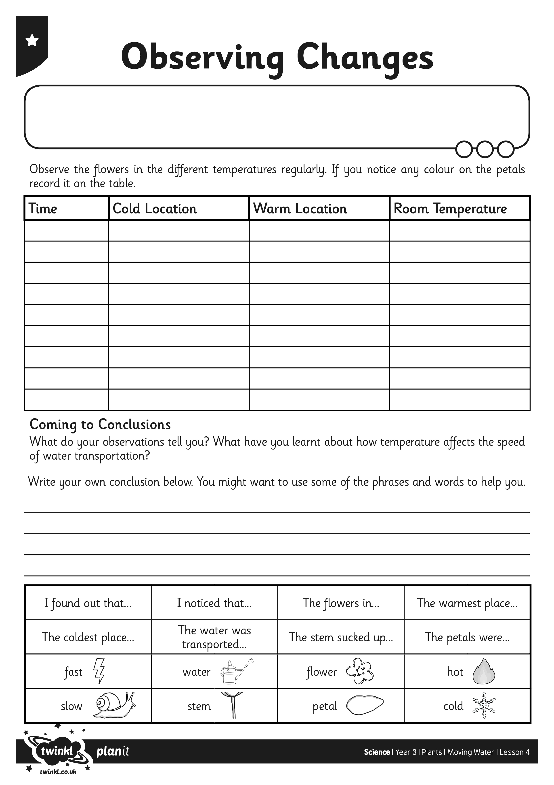
I can investigate how water is transported in plants.
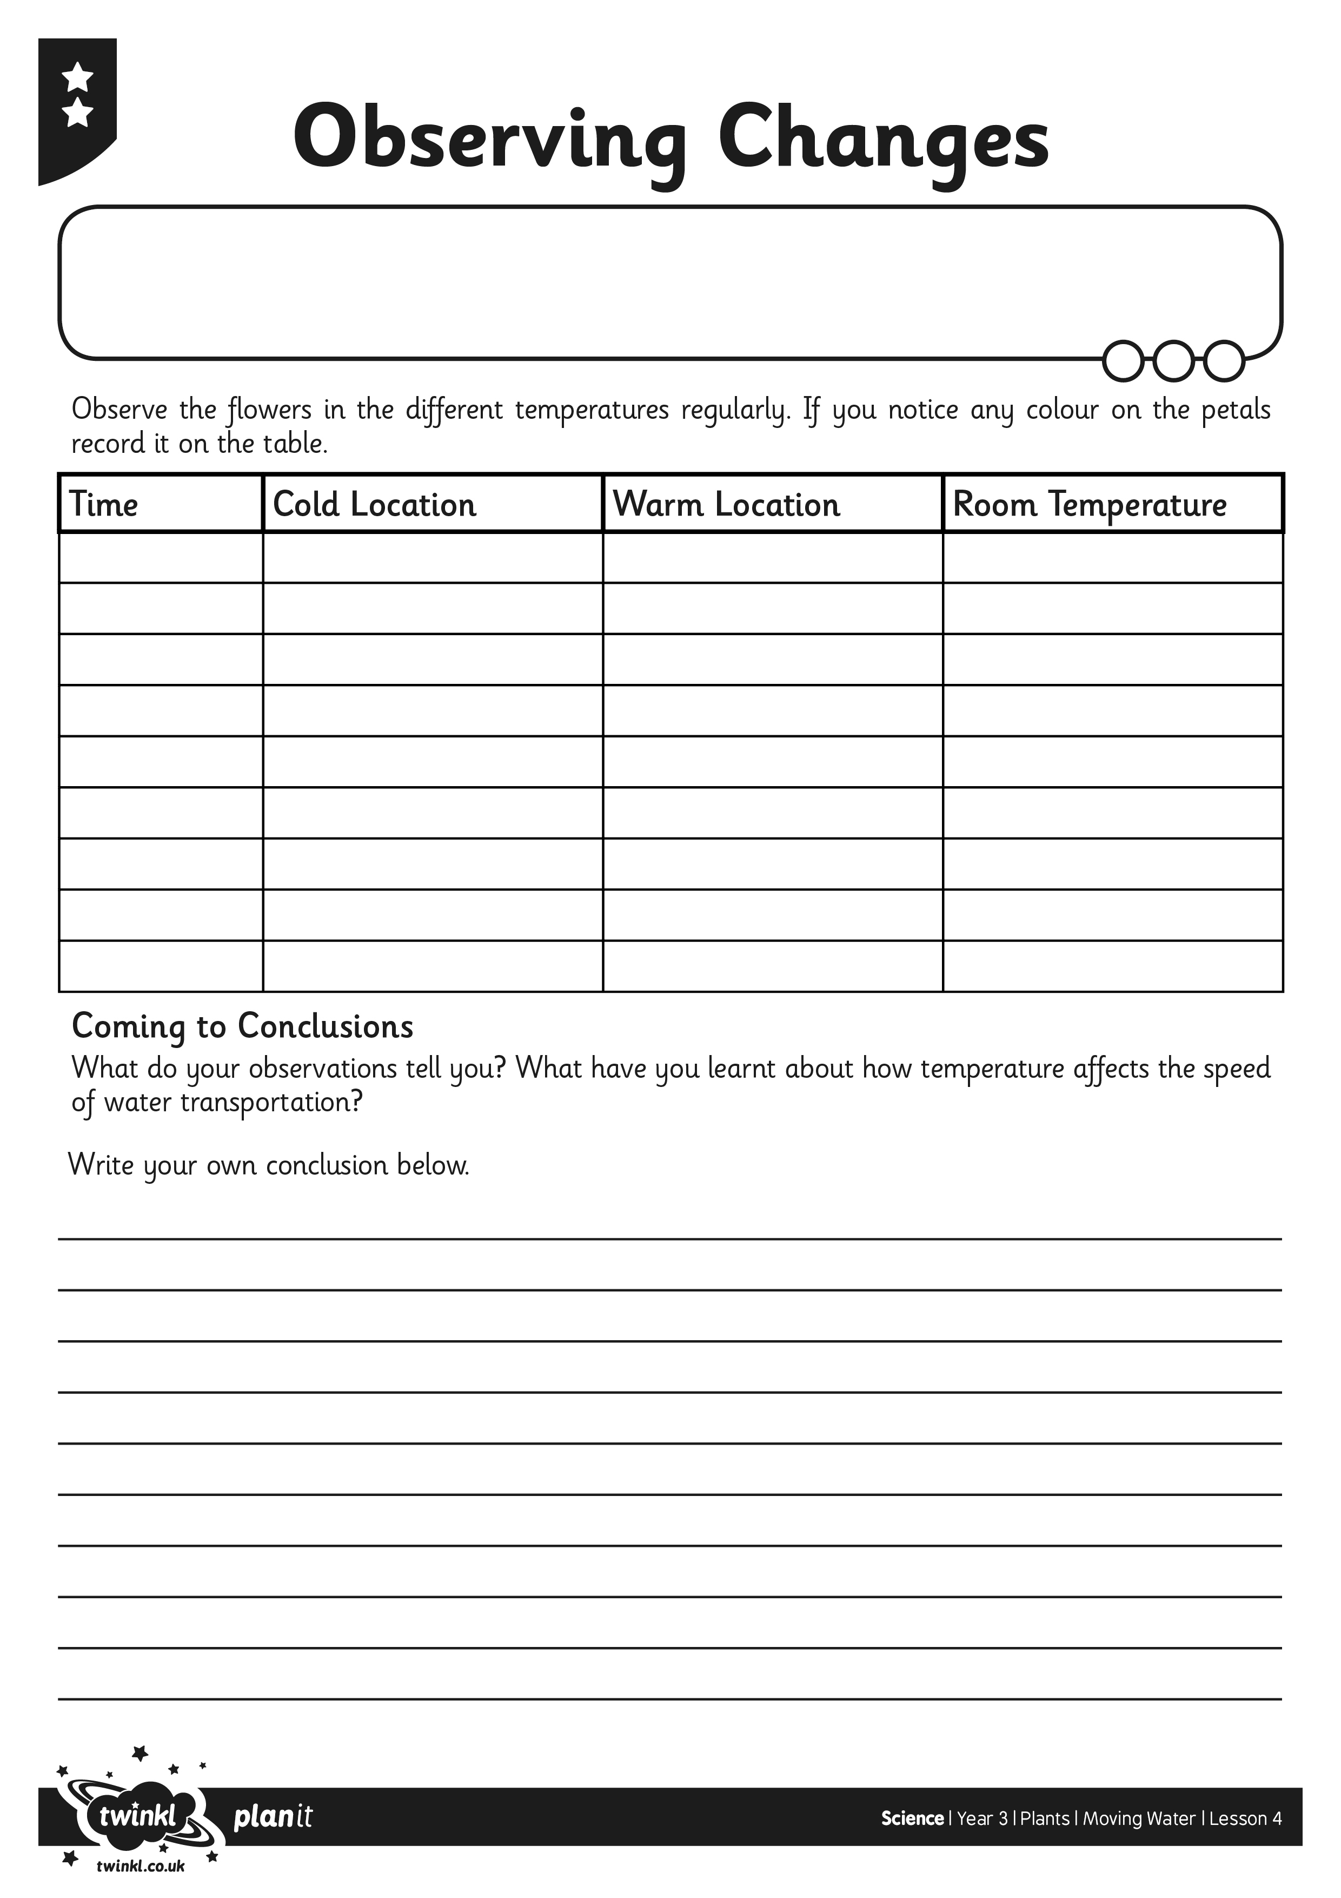
I can investigate how water is transported in plants.

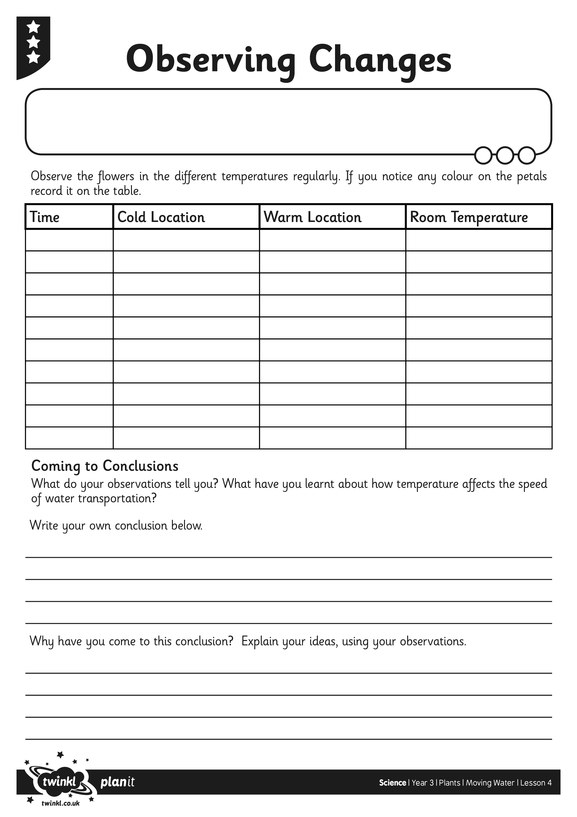
I can investigate how water is transported in plants.

